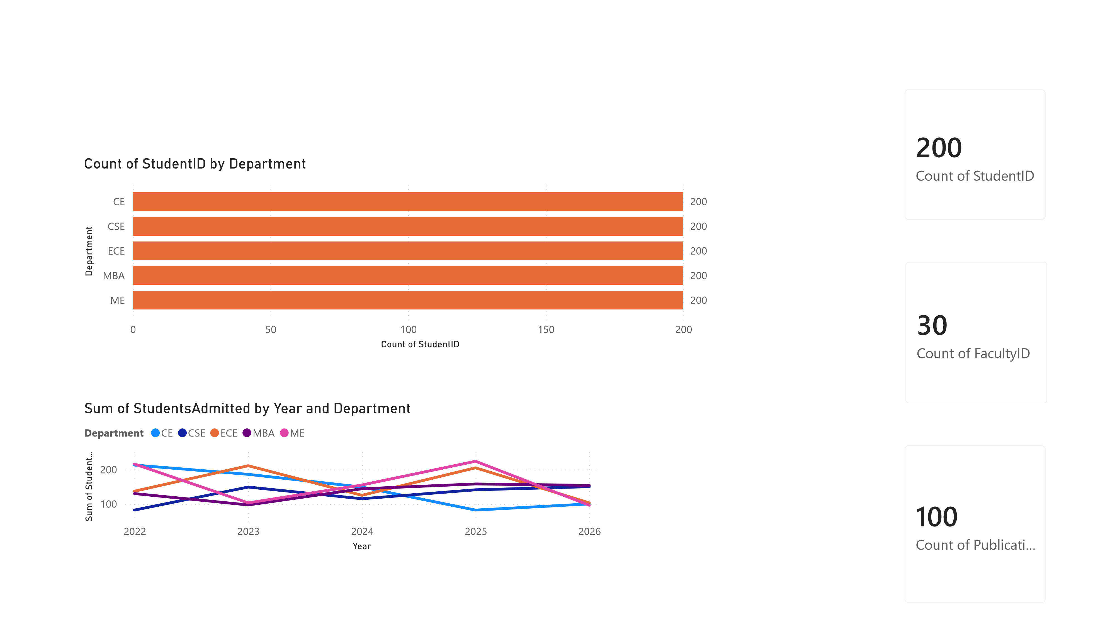

 |  |  | Power BI Desktop
Count of StudentID by Gender |  |  | Count of StudentID by Semester  STUDENT ANALYSIS
56 (46.67%)  Sum of CGPA by StudentID  StudentID  ST001  ST002  ST004  ST005  ST006  ST009  ST011  0 500 | 64  (53.33%  )  1,000 1,500  Sum of CGPA | Gender Male  Female  2,000 | 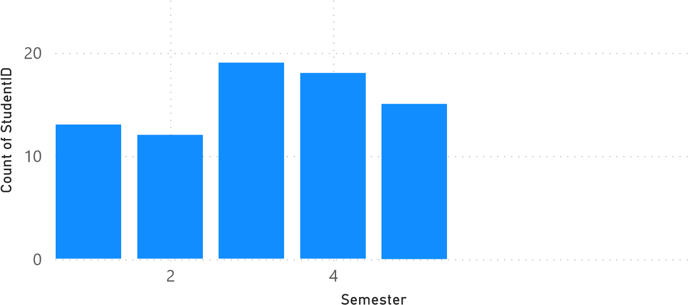  Count of StudentID by Department  0  100  Count of StudentID  CE  CSE  ECE  Department | 6  MBA | ME | 8
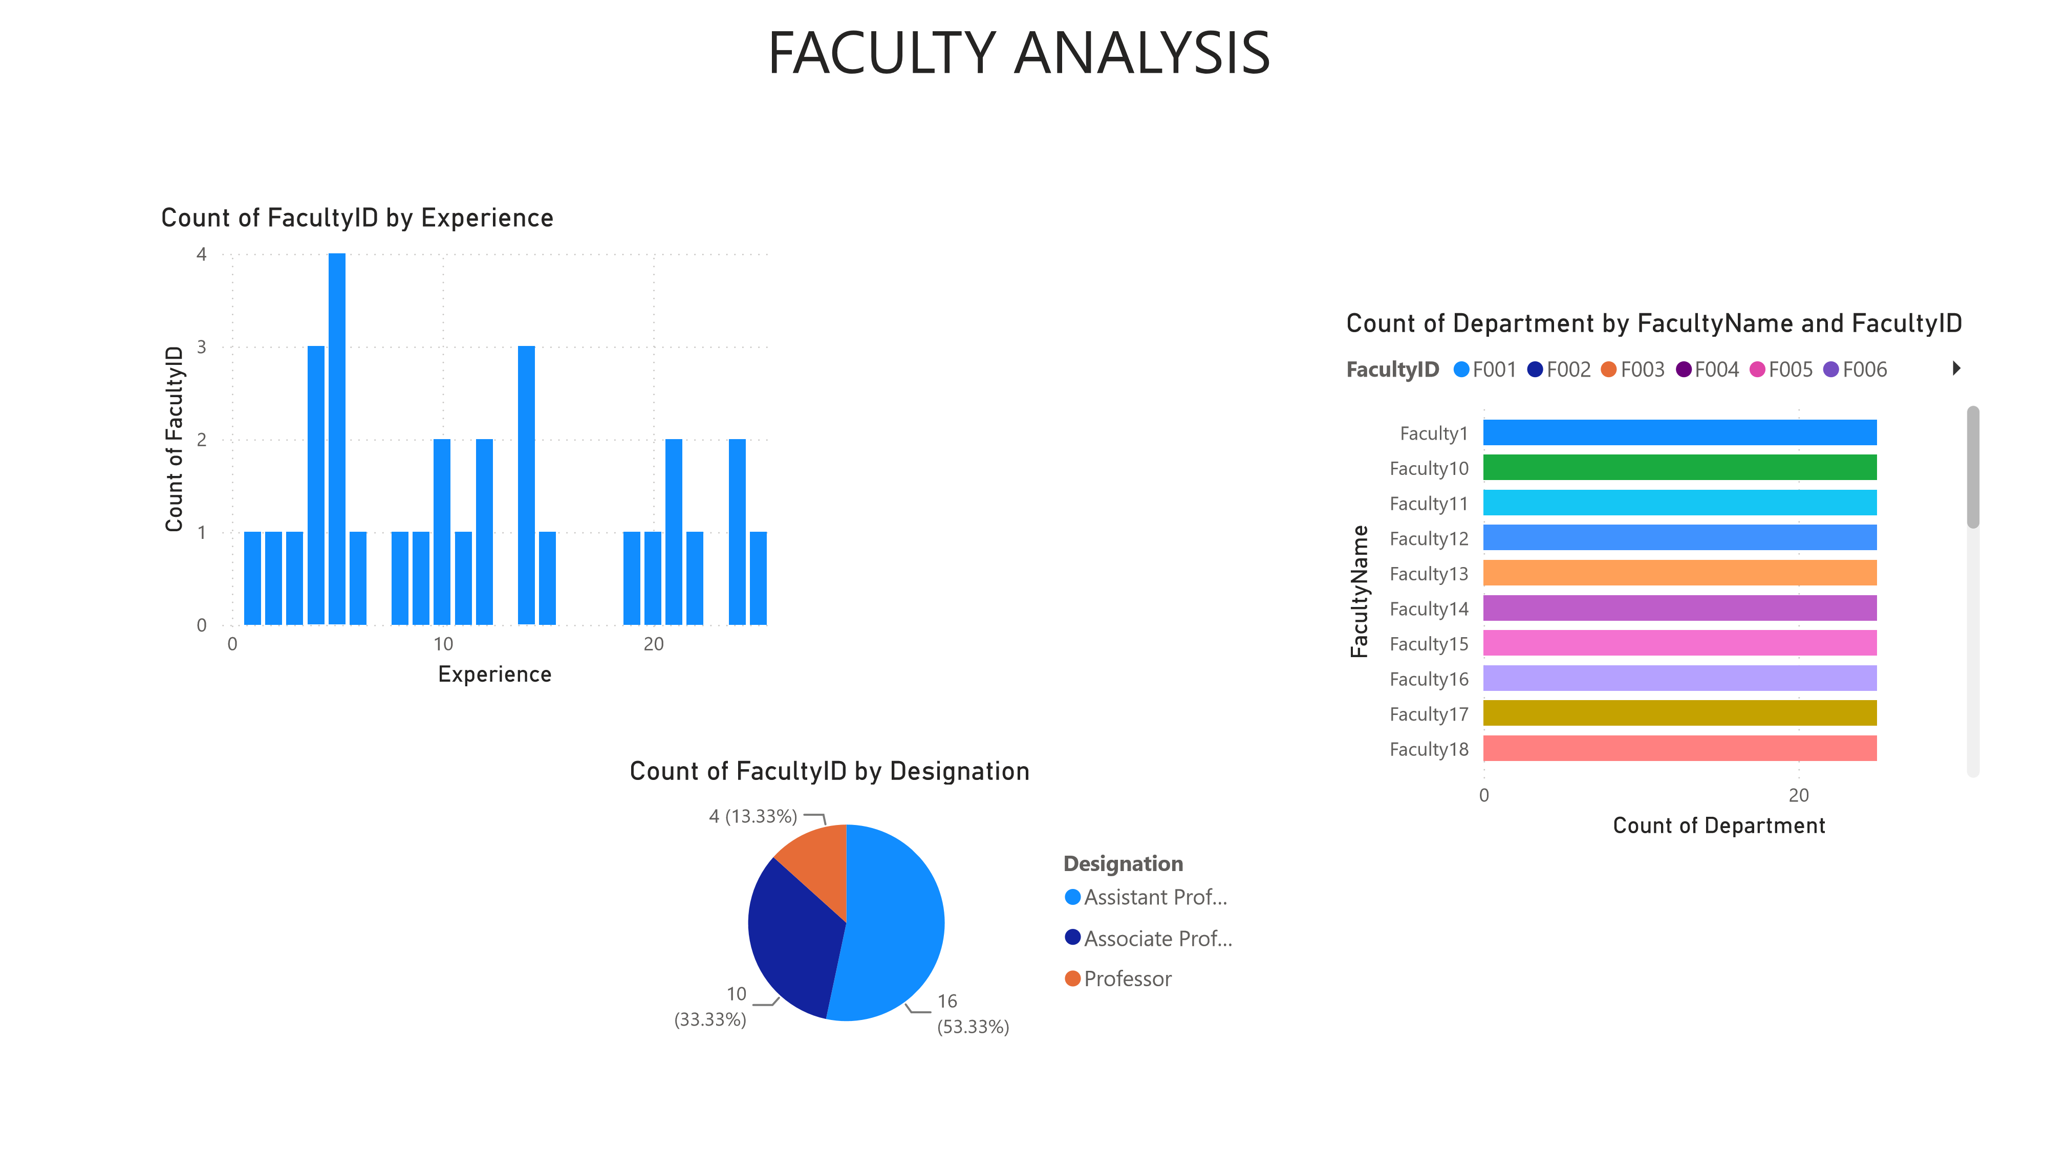
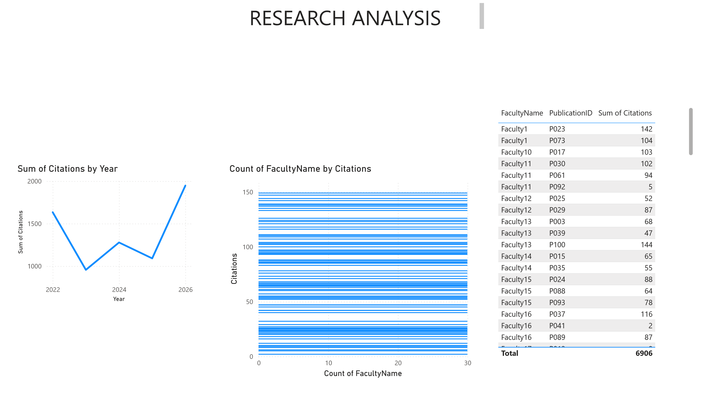

 |  | Power BI Desktop
Count of Department and Sum of
PLACEMENT ANALYSIS
Count of Company by StudentID  0  2  StudentID  ST115  ST043  ST055  ST067  ST084  ST131  ST149  ST009  ST017  ST031  ST051  ST060  Count of Company | 4 | PlacementYear  0.0  M  0.2  M  Count of Department  Sum of PlacementYear  Count of Department and Sum of PlacementYear  Count of StudentID by PackageLPA  